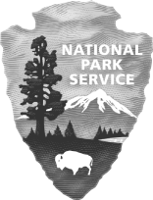
 | Death Valley National Park  National Park Service  U.S. Department of the Interior |  | CA Highway 190  PO Box 579  Death Valley, CA 92328  phone 760.786.3200

Death Valley National Park
News Release
Release Date: February 17, 2021
Contact: Abby Wines, 760-786-3221, abby_wines@nps.gov
Patrick Taylor, 760-786-3279, patrick_taylor@nps.gov

Over one million people enjoyed Death Valley in 2021

DEATH VALLEY, CA – Death Valley National Park welcomed 1,146,551 visitors in 2021. This was about two-thirds of the park’s highest visitation level, set in 2019.

Winter and spring visitation was close to pre-pandemic levels. January through April 2021 had visitation at 86% of record levels.

Most of the drop in visitation was in the summer. Visitation from May through September 2021 was only 38% of 2019 visitation levels. In a typical year, most of the park’s summer visitors are international travelers.

People recreated in the park at high levels again in the fall, which was 88% of record visitation. This year saw the park’s busiest November ever, with 133,130 visitors.

-www.nps.gov/deva-

Death Valley National Park is the homeland of the Timbisha Shoshone and preserves natural resources, cultural resources, exceptional wilderness, scenery, and learning experiences within the nation’s largest conserved desert landscape and some of the most extreme climate and topographic conditions on the planet. Learn more at www.nps.gov/deva.
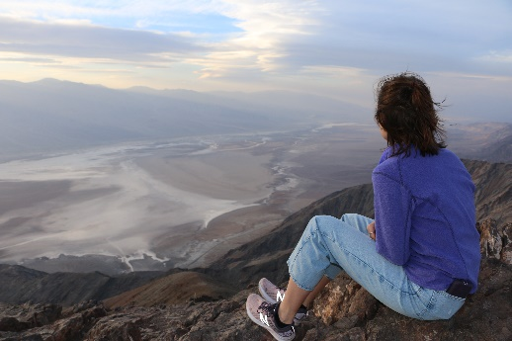
NPS photo
A person enjoys the view from Dantes View, a roadside viewpoint in Death Valley National Park.

